Stigma

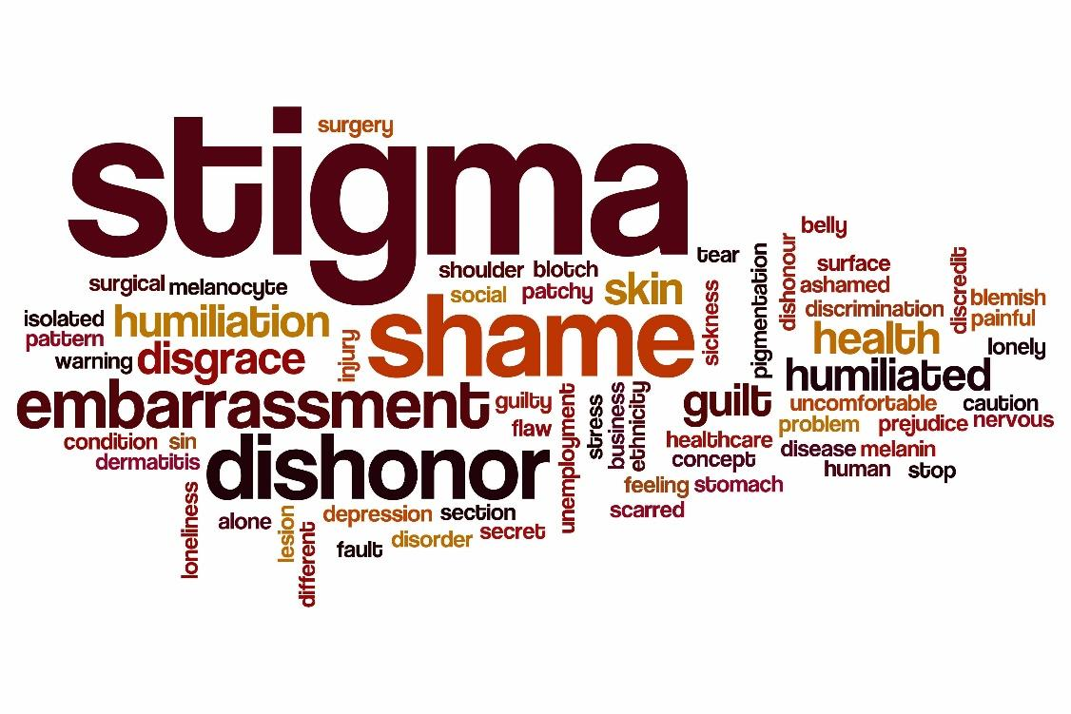

*A mark often associated with the quality of a person.*

**Overview**

This module will explore the stigma related to addiction and steps that can be taken for society to overcome the stigma through better understanding facts. This module will also review appropriate and current language to be used related to addiction and recovery.

**Objectives**

* Recall up to 5 appropriate terms related to addiction;
* Review relevant information from previous modules;
* Recall the four dimensions of recovery; and
* Recognize the ten guiding principles of recovery.

**Stigma Defined**

The World Health Organization (WHO) defines stigma as a set of negative beliefs that a group or society holds about a topic or group of people. Discrimination is often caused by negative stigma. Seeing a person as “less than” because of a brain disorder is shaming and not based on fact, but preconceived notions and ignorance.

Prejudice and discrimination also result in pejorative language, such as: junkie, alcoholic, crack head, and inebriate.

Stigma not only impacts the way a person with Substance Use Disorder feels, but his or her willingness to seek help.

A Howard & Chung [survey](https://www.ncbi.nlm.nih.gov/pubmed/10714451) found that a majority of the nurses surveyed held negative attitudes toward people with addiction. A person who has Substance Use Disorder can feel rejected by society. Being unable to speak to a healthcare provider likely worsens this situation.

Perceived or real, stigma is harmful.

**American Opinion**

Colleen Barry, PhD, MPP, Associate Professor at John Hopkins Bloomberg School of Public Health explained, “While drug addiction and mental illness are both chronic, treatable health conditions, the American public is more likely to think of addiction as a moral failing than a medical condition.”

Barry and her colleagues, Emma E. McGinty, PHD, MS; Bernice A. Pescosolido, PhD; and Howard H. Goldman, MD, PhD completed a survey that is the topic of the journal article, “Stigma, Discrimination, Treatment Effectiveness, and Policy: Public Views About Drug Addiction and Mental Illness”.

Of those who were surveyed,

| **Percent of People Surveyed** | **Indicated they…** |
| --- | --- |
| 62% | Would work with someone with a mental illness. |
| 22% | Would work with someone with Substance Use Disorder. |
| 64% | Believed employers should be able to deny employment to people affected by addiction. |
| 25% | Believed employers should be able to deny employment to those affected by a mental illness. |
| 43% | Opposed giving individuals with substance use disorders the same health insurance benefits granted to otherwise healthy individuals. |
| 21% | Opposed giving those with mental illness the same health insurance benefits given to otherwise healthy individuals (Barry, Mcginty, Pescosolido, & Goldman, 2014). |

**Relevant information from previous modules**

This module reviews information from previous modules with the focus of how increasing knowledge of the process of addiction and the typical life of recovery can inform the public.

**Language**

A person in recovery knows if they are in recovery and how they define recovery for him or herself. The development of a universal definition for recovery is not as important for those in recovery as it is for society.

Over the years, addiction and recovery language have changed.

| **“Old” language** | **“Newer” language** |
| --- | --- |
| Drunkard  Inhibit  Alcoholism  Junkie  Chemical Dependency | Sobriety  Clean time  Deceleration of use  Person in recovery  Substance Use Disorder |

**Language When Seeking Help**

It is important to decrease the shame many feel for having an addiction. Shifting our language can do this. It can also assist to better educate those who may not understand facts about Substance Use Disorder and/or recovery. Many people have a desire to help reduce societal stigma of addiction and recovery by sharing their knowledge and lived experiences. Having one voice and speaking the same language, if you will, is important.

**The Recovery Movement**

The Recovery Movement has turned the focus to community support for people in recovery. A number of significant events occurred in the 2000’s.

* People in recovery, from all walks of life, begin uniting to advocate.
* Training is offered to teach members of anonymous groups how to share about their personal recovery without violating anonymity.
* The Association of Recovery Schools is formed. Recovery High Schools and Collegiate Recovery Programs are being created.
* Recovery Rallies spring up across the country.
* Recovery oriented media grows.
* Peer Recovery Coaching aids people in early recovery.
* A bi-partisan, equity act is signed into law to protect people seeking treatment from being discriminated against.
* The White House Office of National Drug Control Policy creates a Recovery Branch.
* Young people begin finding their voice in recovery advocacy.
* Documentaries about recovery are premiered throughout the United States, including: The Anonymous People film webpage and Generation Found [film webpage.](http://generationfoundfilm.com/)

The recovery movement shifts the focus to ***Recovery Management*** versus historical treatment focusing on Relapse Prevention. Recovery Management is explained as a time-sustained, recovery focused collaboration between service consumers and traditional and non-traditional service providers toward the goal of stabilizing, and then actively managing the ebb and flow of substance use and other co-occurring disorders until full remission and recovery has been achieved, or until they can be effectively self-managed by the individual and his or her family (White, Boyle, Loveland, and Corrington, 2005).

**Recovery Month**

Another tool to help de-stigmatize and educate about recovery is Recovery Month.

Recovery Month began in 1989 as Treatment Works! which honored the work of substance use treatment professionals in the field. The observance evolved into National Alcohol and Drug Addiction Recovery Month in 1998, when it expanded to include celebrating the accomplishment of individuals in recovery from substance use disorders. The observance evolved once again in 2011 to National Recovery Month (Recovery Month) to include all aspects of behavioral health (SAMHSA, 2016).

Annually, Texas has held The Big Texas Rally for Recovery since 2011. The Big Texas Rally for Recovery took place in Austin, Texas at the state capitol from 2011 – 2014. The rally now moves from city to city each year.

2011 – Austin

2012 – Austin

2013 – Austin

2014 - Austin

2015 – Downtown Houston

2016 - Dallas  
2017 - Galveston  
2018 - San Antonio

2019 - DFW

2020 - Virtual

2021 - Houston

2022 - Dallas

2023 - Rallies will be held all over Texas this year!

***[www.bigtexasrallyforrecovery.org](https://bigtexasrallyforrecovery.org/)***

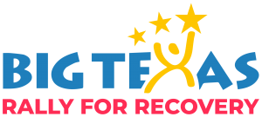

**Terminology**

The addiction counseling profession can often be confusing to new employees due to the many terms, phrases, and acronyms. It might be compared to learning a new language. Become acquainted with the terms, phrases, acronyms and their meaning or descriptions.

Review the [Addictionary](https://www.recoveryanswers.org/addiction-ary/) and become familiar with the terminology.

**Person First Language**

[The Arc for people with intellectual and developmental disabilities](https://www.thearc.org/) explain that about 54 million Americans – one out of every five people – have a disability. They share that people with disabilities are individuals, parents, children, siblings, employees, employers, friends, students, neighbors – before anything else. They go on to explain that the language we use to refer to people with disabilities shapes societal beliefs about them. Person first language makes a dramatic impact. Placing the person before their disability is the general description of what person first means.

As mentioned, many times in this course, language is important and powerful.

[The Texas Council for Developmental Disabilities](http://www.tcdd.texas.gov/) provides an informative [pdf](http://www.tcdd.texas.gov/wp-content/uploads/2012/06/People1st.pdf), People First Language. Review this information. The document provides guidance for what we should say versus what we should not say. An example of what is contained in this document:

| **Say This** | **Not This** |
| --- | --- |
| People with disabilities | The handicapped, the disabled |
| Person who has Down Syndrome | Downs person, mongoloid |
| Person with a physical disability | A cripple |
| Person diagnosed with a mental health condition | Crazy, insane, psycho, mentally ill, emotionally disturbed demented |
| Person diagnosed with a cognitive disability or with an intellectual disability | Mentally retarded, retarded, slow, idiot, moron |

Additions related to addiction:

| **Say This** | **Not This** |
| --- | --- |
| Person with Substance Use Disorder | Addict, Alcoholic, Druggie |
| Person with Bi-Polar Disorder | She or he is Bi-Polar |
| Person in Recovery |  |

**The Language of Substance Use and Recovery: Novel Use of the Go/No-Go Association Task to Measure Implicit Bias**

This is the title of an article written by Ashford, Brown, and Curtis, can be found in the Journal Health Communications. You can find the [full article](https://www.tandfonline.com/doi/full/10.1080/10410236.2018.1481709) here. This article proposes that naming a person (or group) is an act of power and authority and that the language can “subjugate or legitimate” the person (or group). The participants in this research were adults over the age of 18 who were interested in or impacted by Substance Use Disorder. The researchers administered a single test meant to measure implicit bias. The results of this survey suggested that participants had a stronger association with the term “addict” meaning something bad, rather than something good.

The same researchers developed these tools to discuss the impact of the words we use:

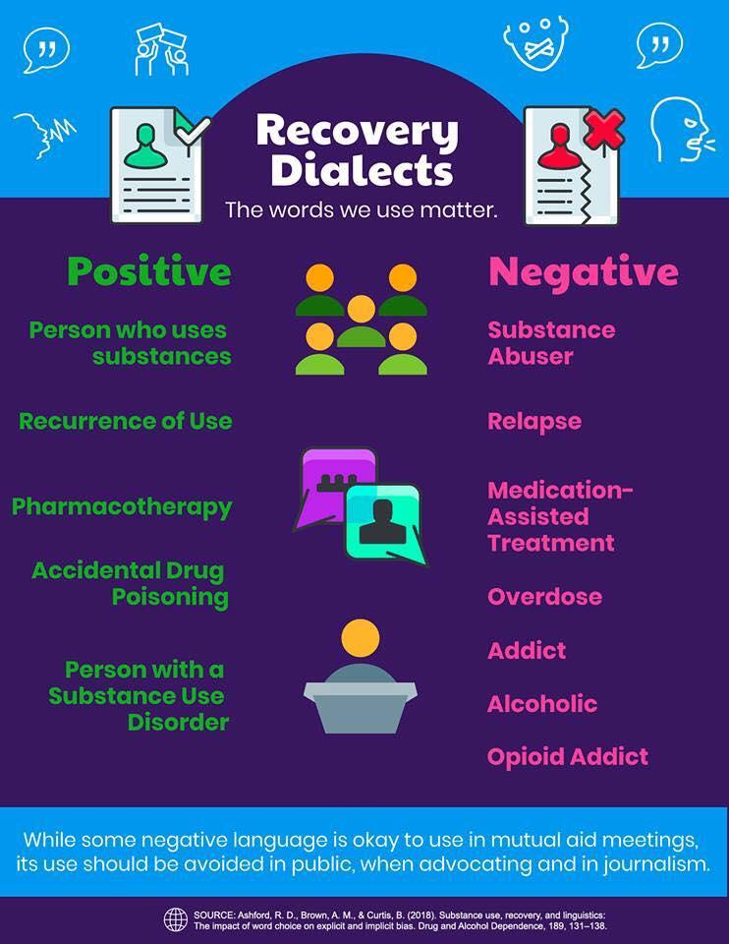

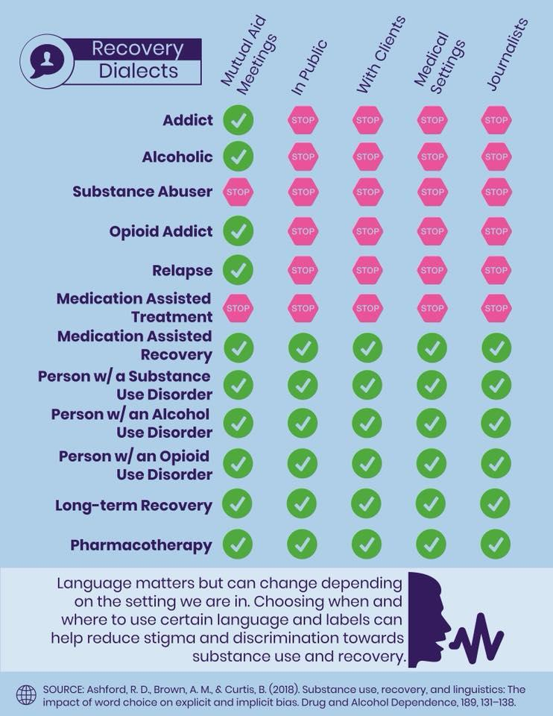**Recovery to Practice Poll**

Review the handout, “Recovery to Practice Poll”. Posing to participants in the Recovery to Practice virtual Communities of Practice, Heller Garland presented the question, *“In your area of expertise, what words or phrases do you want other professionals to stop using / replace and what’s the reason / value for the change?”*

The results were:

| **Say** | **Instead of** |
| --- | --- |
| Recovery Protection | Relapse Prevention |
| Recurrence of Use | Relapse |
| Substance Use Disorder | Substance Abuse |
| Substance Use Disorder | Chemical Dependency |
| Alcohol Use Disorder | Alcoholism/Alcoholic |
| Cocaine Use Disorder | Addict |
| Complete Suicide | Commit Suicide |
| Attempted to die by Suicide | Unsuccessful Suicide Attempt |
| My husband has Borderline Personality Disorder | My husband is so borderline |
| Neuro-typical | People without diagnosis |
| Person with Opiate Use Disorder | Junkie |
| Abstinent of substances | Clean |
| Using substances | Dirty |
| Survivor | Victim |

One of the people polled indicated they often hear the term “addict” and “alcoholic” used by treatment and recovery professionals who are also in recovery.

People in recovery who are not addiction and recovery professionals can use their preferred terminology to describe themselves. Professionals must use the appropriate and respectful language.

Using the terms “Higher Power”, “God”, and “Spirituality” is also cautioned.

Many people use the term “Alcohol and Other Drugs” or AOD. This is dangerous because it separates alcohol from other substances.

**Another area of consideration**

Using diagnostic language for things that are not.

The weather is being bi-polar.

That woman is so narcissistic. She is always taking selfies.

I love a clean house. I am totally OCD.

**Words Matter: How Language Choice Can Reduce Stigma**

A [SAMHSA pdf](https://www.samhsa.gov/capt/sites/default/files/resources/sud-stigma-tool.pdf) with this title can be reviewed. In this paper, SAMHSA’s Center for the Application and Prevention Technologies provides a similar illustration:



Also pointed out:

People with Substance Use Disorder have a fear of being judged and that can keep them from seeking help.

* Substance use disorder is among the most stigmatized conditions in the US and around the world.
* Health care providers treat patients who have substance use disorders differently.
* People with a substance use disorder who expect or experience stigma have poorer outcomes.

**Consider These Five Questions**

In the SAMHSA paper, *Words Matter: How Language Choice Can Reduce Stigma,* they provide these five questions as a way to tell if your prevention messages are stigmatizing.

Ask yourself:

**Are you using “person first” language?**

Person first language (for example, reference to “a person with substance use disorder”) suggests that the person has a problem that can be addressed. By contrast, calling someone a “drug abuser” implies that the person is the problem.

**Are you conflating substance use and Substance Use Disorder?**

While some substance use may be illegal or unhealthy, we should limit language about substance use disorders exclusively to situations where a clinical diagnosis has been made. For prevention practitioners, keeping this distinction clear is key to avoid perpetuating stigmas associated with substance use. For example, a person who has used heroin should not be targeted in the language of a prevention effort aimed at people who meet the clinical definition of opioid addiction or dependence.

**Are you using technical language with a single, clear meaning instead of colloquialisms or words with inconsistent definitions?**

Consider the difference between the terms “negative urine drug screen” and “clean urine.” The first is a clear description of test results; the second a value-laden term that implies drug use creates “dirty” urine. Similarly, “pharmacotherapy for opioid use disorder” is a technical term for medications that can be used to treat an illness, while “substitution/replacement treatment” falsely implies that one opioid is being substituted for another, perpetuating the stigma of “once an addict, always an addict.”

**Are you using sensational or fear-based language?**

Prevention practitioners often walk a fine line between wanting to inspire action and inadvertently inflating the burden of illness and associated consequences due to a health issue. Referring to emerging drug threats as “newer,” “bigger,” “scarier,” or “unlike anything ever seen before” can be perceived as inauthentic by people who use those substances. It further compounds stigma by conveying the message that anyone who uses such a “terrible” substance is stupid, dangerous, or illogical.

**Are you unintentionally perpetuating drug-related moral panic?**

From publicizing stories about “crack babies” in the 1980s to “opioid babies” today, the tendency toward moral panic has a long history in prevention messaging and media coverage of substance use disorders. Moral panics inevitably marginalize people who are vulnerable and often bring their morality or even humanity into question. This moral panic may prevent mothers who use drugs from accessing prenatal care because they are afraid of being judged or mistreated by medical professionals, or of being forced into the child welfare system.

Review Page 4 of the SAMHSA CAPT (Center for the Application of Prevention Technologies) paper for tips for avoiding the use of stigmatizing language.

Watch the Ted Talk by Lera Boroditsky, [How Language Shapes the Way we Think](https://www.bing.com/videos/search?q=ted+talk+how+language+shapes+the+way+we+think&view=detail&mid=002A6602EF47B129A558002A6602EF47B129A558&FORM=VIRE). As with all Ted Talks, the transcript of the video is provided at the bottom of the video.

Read this article, “[The Real Stigma of Substance Use Disorders](https://www.recoveryanswers.org/research-post/the-real-stigma-of-substance-use-disorders/): Does it Matter How We Talk About People with Substance Use Disorder?”

**References**

Ashford, R. D., Brown, A. M., & Curtis, B. (2018). The Language of Substance Use and Recovery: Novel Use of the Go/No–Go Association Task to Measure Implicit Bias. *Health Communication,* 1-7. doi:10.1080/10410236.2018.1481709.

Barry, C. L., Mcginty, E. E., Pescosolido, B. A., & Goldman, H. H. (2014). Stigma, Discrimination, Treatment Effectiveness, and Policy: Public Views About Drug Addiction and Mental Illness. *Psychiatric Services,* *65*(10), 1269-1272. doi:10.1176/appi.ps.201400140.

Howard, M. O., & Chung, S. S. (2000). Nurses Attitudes toward Substance Misusers. I. Surveys. *Substance Use & Misuse,* *35*(3), 347-365. doi:10.3109/10826080009147701.

SAMHSA's CAPT. (2017, November). Words Matter: How Language Choice Can Reduce Stigma. Retrieved September 05, 2018.

Texas Council for Developmental Disabilities. (n.d.). Retrieved from http://www.tcdd.texas.gov/

The Arc | For People with Intellectual and Developmental Disabilities. (n.d.). Retrieved from <https://www.thearc.org/>