**Diverse Populations**

**in Recovery**

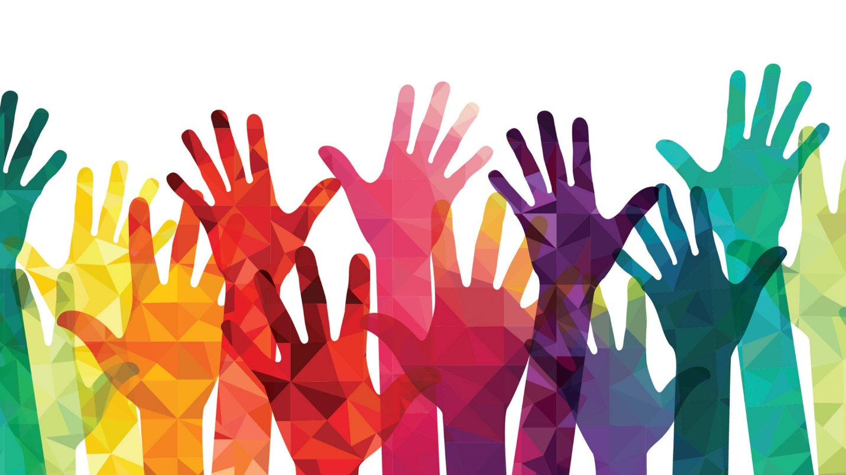

*It is time for parents to teach young people early on that in diversity there is beauty and there is strength.*

*~* [*Maya Angelou*](https://www.mayaangelou.com/)

**Overview**

Many elements contribute to the unique needs of people in recovery. This module will highlight a few diverse populations we often work with in addiction and recovery. Keeping in mind each person’s diversity can lead to more robust treatment.

**Objectives**

* Discuss 3 concerns facing justice involved individuals;
* Recall 3 issues discussed in this module about specific diverse populations; and
* Identify the importance of treating each person as an individual.

**Diversity**

Merriam-Webster’s definitions:

**Diverse**

1: differing from one another: [unlike](https://www.merriam-webster.com/dictionary/unlike)

2: composed of [distinct](https://www.merriam-webster.com/dictionary/distinct) or unlike elements or qualities

**Diversity**

1: the condition of having or being composed of differing elements: [variety](https://www.merriam-webster.com/dictionary/variety); *especially*: the inclusion of different types of people (such as people of different races or cultures) in a group or organization

2: an instance of being composed of differing elements or qualities: an instance of being [diverse](https://www.merriam-webster.com/dictionary/diverse)

Multiculturalism, Cultural Diversity, Cultural Competency. Each of these are titles you might have heard to describe this topic. The addiction and recovery profession currently use Cultural Competency as the most up-to-date and appropriate way to describe this topic. Cultural Competency will be covered in more depth in another module.

**Multiculturalism**

Multiculturalism is defined by [Chegg Study](https://www.chegg.com/) as:

The view that cultural differences should be respected or even encouraged. Sociologists use the concept of multiculturalism to describe one way of approaching cultural diversity within a society. Underlying multiculturalism is the belief that members of different cultures can live peacefully alongside each other; assimilation is not necessary, nor perhaps even desirable.

Chegg Study also provides a [video](https://www.chegg.com/homework-help/definitions/multiculturalism-49), with a transcript, discussing multiculturalism.

**Cultural Diversity**

In his course on Study.com, [*Effective Communication in the Workplace*](https://study.com/academy/lesson/defining-cultural-diversity.html#lesson), Instructor David White, describes Cultural Diversity as:

the term used to describe many different cultures co-existing within one larger culture. For instance, the fact that we have access to so many different types of cuisine in the United States is because people from other countries have immigrated to the US and brought aspects of their own cultures with them. This means that under the umbrella of American culture there are actually many different ethnic traditions being practiced in communities around the country (White, n.d.).

**Cultural Competency**

Described in a brief from Georgetown University from a healthcare perspective:

“the ability of providers and organizations to effectively deliver health care services that meet the social, cultural, and linguistic needs of patients” (Cultural Competence in Healthcare: Is it Important for People with Chronic Conditions?, 2004)

Review the data related to [Access to Healthcare](https://hpi.georgetown.edu/agingsociety/pubhtml/cultural/cultural.html) differing by race and ethnicity.

**Diversity of Populations in need of Treatment**

There are many diverse populations in need of treatment for Substance Use Disorder (SUD). The Substance Abuse and Mental Health Services Administration (SAMHSA) discussed the following as diverse populations:

|  |  |  |
| --- | --- | --- |
| **Racial and Ethnic Populations** | | |
| African American | American Indians | Alaska Natives |
| Asian Americans | Hawaii Natives | Hispanic and Latino |
| Pacific Islanders |  |  |

|  |  |  |
| --- | --- | --- |
| **Age and Gender Based Populations** | | |
| Children | Bisexual | Families |
| Gay | Infants | Lesbian |
| Men | Older adults | Pregnant Women |
| Transgender individuals | Women | Youth |

|  |  |  |
| --- | --- | --- |
| **Other areas to consider** | | |
| Age | Economic Status | Education |
| Geographic Location | People experiencing homelessness | People involved with the criminal justice system |
| People who live in rural areas | Sexual Orientation | Veterans and Military Families |

In the resource section of this module, you can find links to surveys for these diverse populations as they relate to mental health issues and substance use.

**SAMHSA Findings**

This information references “Substance Abuse” and other language used in 2014, as that is when much of this research was conducted. The quotes are taken directly the SAMHSA website. SAMHSA reports are broken down into race and are found on the following pages.

**African Americans**

There are about 44.5 million **African Americans** in the United States (about 14.2% of the total population).

The rate of illegal drug use in the last month among African Americans ages 12 and up in 2014 was 12.4%, compared to the national average of 10.2%.

The rate of binge drinking among African Americans ages 12 and up was 21.6%–compared with the national average of 23%.

African Americans ages 12 to 20 in 2014 reported past-month alcohol use at a rate of 17.3%, compared with the national average of 22.8%. Past-month underage binge drinking was 8.5% for African American youth, while the national average was 13.8%.

**American Indians and Alaska Natives**

There are about 5.2 million **American Indians and Alaska Natives** in the United States (about 1.7% of the total population). American Indians and Alaska Natives experience some of the highest rates of substance use and mental disorders compared to other U.S. racial or ethnic groups. For instance:

The rate of illegal drug use in the last month among American Indians and Alaska Natives ages 12 and up in 2014 was 14.9%.

American Indians and Alaska Natives ages 12 to 20 in 2014 reported past-month alcohol use at a rate of 21.9%, compared with the national average of 22.8%.

Past-month underage binge drinking was 14.3% for American Indian and Alaska Native youth, while the national average was 13.8%.

In 2010, Native Americans had the highest rate of drug-induced death (17.1%).

Additional information can be found by viewing this [fact sheet](https://www.cdc.gov/violenceprevention/pdf/suicide-datasheet-a.pdf) published by the Centers for Disease Control and Prevention regarding the suicide rates for American Indians and Alaska Natives.

**Hispanic or Latinos**

There are about 52 million Hispanic or Latinos in the United States (about 16.7% of the total population). By 2050, the number of people in this population group is expected to double to about 132.8 million, making up approximately 30% of the total U.S. population.

The rate of illicit drug use in the past month among Hispanic individuals ages 12 and up was 8.9%, while the national average was 10.2%.

The rate of binge alcohol use among Hispanics or Latinos within this age group was 24.7%. Alcohol use in the last year among people ages 12 to 17 was 23.9% for Hispanic youth.

These finding can be confirmed in the [Substance Use and Mental Health Indicators in the United States: Results from the 2015 National Survey on Drug Use and Health.](https://www.samhsa.gov/data/sites/default/files/NSDUH-FFR1-2015/NSDUH-FFR1-2015/NSDUH-FFR1-2015.pdf)

**Texas**

In 2003, the US Census reported more than 11% of people living in America are foreign born. This is the highest in US history.

The 2007 US Census found half of the Hispanic/Latinos in the United States live in Texas and California. 14% of the United States population are Hispanic/Latino. This is the largest ethnic sub-population in the United States. **Justice Involvement**

Based on information found through SAMHSA, a report from 2006 by the Bureau of Justice Statistics, indicated 74% of state prisoners, 63% of federal prisoners and 76% of jail inmates met the criteria for a mental health disorder. Also, 42% of state prisoners and 49% of jail inmates met the criteria for *both* a mental health and substance use disorder.

The Office of National Drug Control Policy (ONDCP) reported only 4 in 10 offenders needing treatment reported receiving treatment services while incarcerated.

**Terminology Change**

Use the term “justice involved” rather than:

* Criminal
* Felon
* Probationer
* Parolee

**Issues for the Justice Involved**

SAMHSA indicates the issues faced by the justice involved can include:

* little access to health care;
* limited job skills;
* incomplete education;
* lack of stable housing;
* poor connection with community behavioral health providers; and
* lengthy waiting periods for benefits and receipt of other community services.

Many of these issues can jeopardize recovery and increase the probability of recurrence of use and re-arrest.

For instance, a person on probation who has been determined to have Substance Use Disorder may be ordered to:

* Have full-time gainful employment;
* Attend an Intensive Outpatient Program (IOP);
* Pay probation fees;
* Pay additional fees (example: urine screen at probation and treatment facility);
* Pay restitution related to the crime;
* Visit probation officer in probation office once each week – once each month;
* Be available for probation officer visit to home;
* Provide urine screen within 24-hours of being told to do so.

Each of these requirements are likely designed for accountability and change; however, do not take into consideration:

* Work missed for each;
* Transportation;
* Pay rate;
* Family obligations;
* Difficulty obtaining employment with criminal record;
* Other bills.

Online access to more information related to [SAMHA’s efforts](https://www.samhsa.gov/criminal-juvenile-justice) in the “criminal and juvenile justice”.

[Additional publication](https://www.samhsa.gov/criminal-juvenile-justice/publications-resources) are available through the SAMHSA clearinghouse.

**Nora Volkow**

Nora Volkow, M.D. was Director of the National Institute on Drug Abuse ([NIDA](https://www.drugabuse.gov/about-nida)) at the National Institutes of Health from 2003 – 2006 and has contributed a great deal to furthering public understanding of Substance Use Disorder.

NIDA supports most of the world’s research on the health aspects of addiction.

Review Volkow’s work on the Criminal Justice Approach:

In the 2016 United Nations General Assembly Special Session on drugs (UNGASS 2016), where it was unanimously approved by the 193 Member States, to recognize “drug addiction as a complex multifactorial health disorder characterized by chronic and relapsing nature”. Nora D. Volkow, provides an in-depth review in [*Drug Use Disorders: impact of Public Health rather than a Criminal Justice approach.*](https://www.ncbi.nlm.nih.gov/pmc/articles/PMC5428163/)

**Frank Davis, M.Ed., LCDC, AADC, CCJP**

Frank is the Program Director, Gateway Foundation and Texas Certification Board of Addiction Professionals (TCBAP) Chair. Frank has contributed to the addiction and recovery field throughout his career. Some of his contributions include: International, national, state, and regional conference presentations; LCDC test preparation courses; Adjunct Professor at San Antonio College; and development of the LCDC test.

Frank is also a member of the UNT Recovery to Practice Advisory Board. He created the slide deck “***Criminal Justice Systems and Processes”*** included in this module’s resources.

**Gender Identity**

**SOGIE** is an acronym that stands for Sexual Orientation, Gender Identity, and Gender Expression. This acronym is inclusive of everyone, not only those who identify as homosexual. The reason this term is inclusive is that everyone has a sexual orientation, gender identity, and gender expression.

The University of Connecticut Rainbow Coalition produced an informative [fact sheet](https://rainbowcenter.uconn.edu/wp-content/uploads/sites/786/2016/04/SOGIE-flier-4.7.16.pdf) describing SOGIE that you may find useful.

In a [blog post,](https://www.be-inclusive.com/newest-posts/2016/4/13/how-to-explain-sogie-to-newbies) Si Min Chong describes How to explain ‘SOGIE’ to newbies.

In an attempt to provide equitable care for youth, the Alameda County Department of Children and Family Services created a confidential “[SOGIE Questionnaire](http://www.cfyetf.org/education-summit_17_2361847496.pdf)” What are your thoughts on this project?

UC Davis provides an LGBTQIA Resource Center [Glossary of terms](https://lgbtqia.ucdavis.edu/educated/glossary.html).

**Equity Project**

In 2005 The National Juvenile Defender Center and The Equity Project examined issue impacting LGBT youth involved in the juvenile justice system. This study was comprehensive, following the youth from the onset of their involvement to post-involvement.

These findings are available in the [online pdf](http://www.equityproject.org/wp-content/uploads/2014/08/hidden_injustice.pdf), Hidden Injustice: lesbian, gay, bisexual, and transgender youth in juvenile courts.

Issues found in the Executive Summary include:

* Common misconceptions about, and biases against, LGBT youth negatively impact how the juvenile justice system responds to them;
* Believed myth that juveniles, because of their age, cannot be LGBT;
* Believed myth that sexual orientation or gender identity are a matter of choice and can be changed;
* Some professionals in the juvenile justice system attempt to change, control, or punish LGBT adolescent sexual orientation and gender identity;
* Family rejection of LGBT youth increases the risk of their involvement in the juvenile justice system and negatively impacts their cases;
* At every stage of the process, services and placements competent to serve LGBT youth are lacking;
* LGBT youth are unnecessarily and disproportionately detained pending trial because of a lack of understanding of their life experiences;
* LGBT youth experience egregious conditions of confinement in detention and other secure facilities; and
* Delinquency courts fail to protect the due process rights of LGBT youth, particularly the right to effective counsel.

Some of these finding speak to professionals allowing their personal bias to crowd their professional decision-making. There is no place for that behavior in the helping profession. In the module related to culture there will be more in-depth discussion of bias.

**Population Specific Links**

[Co-Occurring Disorders in the Criminal Justice System](https://www.samhsa.gov/disorders/co-occurring#criminal-justice)

[Co-Occurring Disorders and Homelessness](https://www.samhsa.gov/disorders/co-occurring#homelessness)

[Co-Occurring Disorders and Primary Care](https://www.samhsa.gov/disorders/co-occurring#primary-care)

[Co-Occurring Disorders Among Veterans and The Military Community](https://www.samhsa.gov/disorders/co-occurring#military)

[Definitions and Terms Relating to Co-Occurring Disorders](https://store.samhsa.gov/shin/content/PHD1130/PHD1130.pdf)

**The National Network to Eliminate Disparities in Behavioral Health (**[**NNED)**](http://www.nned.net/nned_overview/)

[NNED](http://www.nned.net/nned_overview/) was formed by Substance Abuse and Mental Health Services Administration (SAMHSA) and the National Alliance of Multi-ethnic Behavioral Health Associations (NAMBHA).

NNED and the National Alliance on Mental Illness ([NAMI)](https://www.nami.org/) has been partnering to raise awareness during National Minority Mental Health Awareness Month is each July.

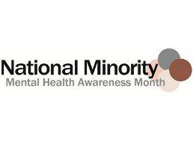

**Women in Treatment**

As are most publications available through SAMHSA, [Substance Abuse Treatment Addressing the Specific Needs of Women](https://www.store.samhsa.gov/product/TIP-51-Substance-Abuse-Treatment-Addressing-the-Specific-Needs-of-Women/SMA15-4426) is a free publication through SAMHSA. You may obtain this publication as an electronic copy by downloading it from the SAMHSA Clearinghouse or order one, at no cost, to be delivered to you.

**Perspective Paper**

Gallup has a variety of articles, papers, and guides related to Diversity and Inclusion. In a Perspective Paper, Gallup proposes three necessary components of including all cultures in the workplace:

**In an inclusive culture:**

1. Everyone treats everyone else with respect.
2. Managers appreciate the unique characteristics of everyone on their team.
3. Leaders do what's right (Gallup, Inc, 2018).

**Penn State**

Review the [Diversity Discussion Starters](https://www.mentoring.org/new-site/wp-content/uploads/2015/12/Diversity-Discussion-Starters.pdf) created by Penn State in an effort to illicit discussions about diversity. This package contains ice-breakers you could use in many different settings, including counseling groups.

**References**

Dean L., Meyer I.H., Robinson K., Sell R.L., Sember R., Silenzio VMB, Bowen D.J., Bradford J., Rothblum E., Scout White J., Dunn P., Lawrence A., Wolfe D., Xavier J., Lesbian, gay, bisexual, and transgender health: Findings and concerns. Journal of the Gay and Lesbian Medical Association. 2000; 4(3): 101 – 151.

Gallup, Inc. (2018). Gallup Services. Retrieved from

<https://www.gallup.com/topic/gender_equality.aspx>

*Cultural Competence in Health Care: Is it important for people with chronic conditions?* (Issue brief No. 5). (2004). Washington, DC: Georgetown University.

White, D. (n.d.). Defining Cultural Diversity. Retrieved from https://study.com/academy/lesson/defining-cultural-diversity.html